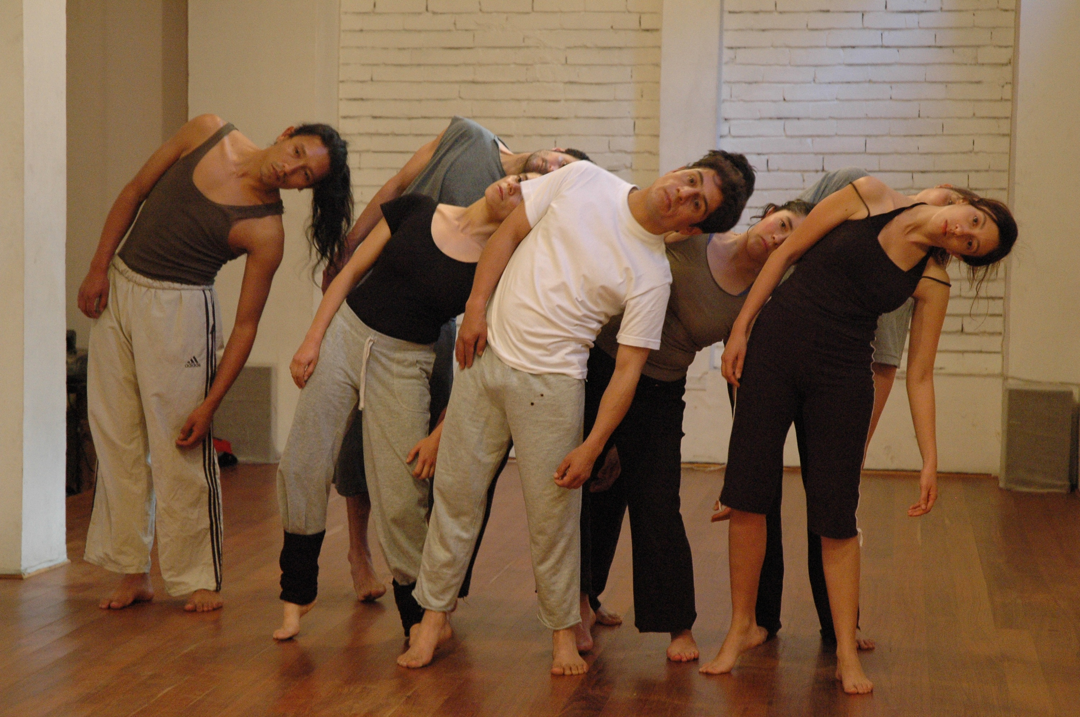

**How do we combine the precision of training with creative and organic energy?**

**Is it posible to mix two different languages aiming for the same result?**

**What principles that begin in an actor’s training feed a creative process?**

This workshop laboratory seeks to research the links between organic movement and precision as a source of work for the actor, thus creating a dramaturgy that weaves two parallel processes: one in which the actor is receptive to the space and reacts to the impulses that eventually lead them to an action; the other in which technique serves as a means for expression and composition.

Working with common principles taken from corporeal mime and movement training for actors,

the participants in the workshop will explore:

Flow and organic movement

Principles of weight, gravity and vertical presence

Listening to body and space

Spatial composition

Dramaturgy of the actor

The rhythm of action

Improvisation and play

ACTION: BETWEEN PRECISION AND SPONTANEITY

Led by Columbian actress, corporal mime workshop leader and movement lecturer Gina Paola Gutierrez



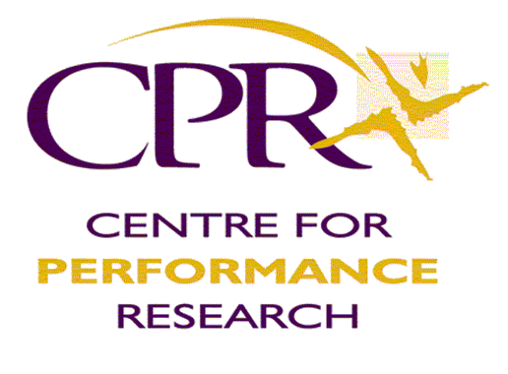

To get more info about the workshop contact:

info@thecpr.org.uk

[thelisteningbody@gmail.com](mailto:thelisteningbody@gmail.com)

or see <http://www.thecpr.org.uk/projects/workshops.php>

CPR invites you to the workshop-laboratory:

30th JULY – 12th AUGUST 2012, Aberystwyth, Wales

2 Week, 1 Week or Weekend workshop options available

# Nam lobortis felis sed est commodo posuere.

kijiuTTTTTThihh